

Project and Professionalism

(6CS007)

Project Proposal Report

Survey Equipment Rental

Full Name : Mausham Dhakal

Student ID : 2358836

Group :L6CG19

Email : Np03cs4s230090heraldcollege.edu.np

Supervisor : Nikunja Lamsal

Reader : Shiv Kumar Yadav

Submission Date : 12-01-2024

Word Count :2900

**Abstract**

This project focuses on the development of an e-commerce platform for renting survey equipment, aimed at addressing the challenges faced by surveyors and small businesses in accessing high-cost tools. The platform will streamline the equipment rental process by providing features like easy browsing, real-time availability checks, secure bookings, and dynamic pricing. Using React.js for the frontend and Node.js for the backend, the platform will offer a scalable and user-friendly interface, ensuring seamless transactions and enhanced user experiences. By implementing Agile Scrum methodology, the project will be developed iteratively, prioritizing user feedback and adaptability. Ultimately, the platform seeks to improve accessibility, operational efficiency, and cost-effectiveness, making survey equipment rentals more convenient and sustainable for independent surveyors and businesses in Nepal.

**Table of Contents**

**1. Statement of Project Details** 5

**1.1 Project Title:** 5

**1.2 Academic Question** 5

**1.3 Aims** 5

**1.4 Objectives** 5

**1.5 Artefact (Proposed) to be Developed** 6

**2. Project Proposal** 7

**2.1 Introduction** 7

**2.1.1 Problem Scenario** 7

**2.1.2 Project as a Solution** 8

**2.2 Initial Research into sources of Information** 8

**Literature Review 1:** 9

**Literature Review 2:** 9

**2.3 Artefact (Proposed)** 10

**2.3.1 FDD Diagram** 10

**2.3.2 Justification related to Academic Question** 10

**2.3.3 Consideration of Other Artefacts** 11

**2.3.5 Full Details of Artefact** 12

**2.3.6 Development Approach** 12

**2.3.7 Justification of Methodology** 12

**2.3.8 Tools and Techniques** 13

**2.3.9 Planned Testing** 14

**3. Plan/Schedule** 15

**4. Additional Information** 16

**4.1 Resources** 16

**4.2 Client** 16

**References** 16

Table of Figures

Figure 1: FDD Diagram 10

Figure 2: Scrum Methodology 12

Figure 3: Gantt Chart 15

# **1. Statement of Project Details**

## **1.1 Project Title:**

**Survey Equipment Rental**

## **1.2 Academic Question**

* How can an e-commerce platform simplify survey equipment rentals for better customer retention?
* How can accessibility and efficiency in survey equipment rentals be improved through e-commerce?
* How can an e-commerce platform optimize costs and support growth for small survey businesses?

## **1.3 Aims**

* To develop an intuitive online platform that allows customers to easily browse, select, and rent survey equipment based on their needs and budget, with clear and flexible pricing options.
* To enhance the overall user experience by streamlining the rental process, ensuring it is quick, secure, and reliable, with transparent pricing to build customer trust and encourage repeat business.
* To create a scalable system that can handle a growing number of users, a diverse range of survey equipment, and dynamic pricing adjustments as demand increases, ensuring long-term growth and adaptability.

## **1.4 Objectives**

* Develop a user-friendly platform that enables people to easily browse, select, and rent survey equipment based on their specific needs.
* Implement secure user authentication and online payment systems to ensure safe and seamless transactions during the rental process.
* Introduce a dynamic pricing model to provide competitive rental rates and optimize revenue based on demand fluctuations.
* Create a feedback system where users can share experiences and rate equipment to enhance trust and aid decision-making for future rentals.

## **1.5 Artefact (Proposed) to be Developed**

* **User Registration and Login**:

Users must register on the platform to access all rental features. After successful registration, users can manage their profile, make equipment bookings, and track rental history.

* **View and Update Profile**:

Registered users can view their profiles, including their rental history and equipment preferences. They can also update personal information, such as contact details, password, and payment methods.

* **Browse and Filter Survey Equipment**:

Users can browse the available survey equipment, such as total stations, GPS devices, Theodolite, Level machine and drones. They can filter the equipment list by type, price and availability

* **Book Equipment**:

Once users select their desired equipment, they can easily proceed to make a booking by selecting the rental duration, payment method, and providing delivery/pickup preferences. The platform will display the total rental cost and availability of the equipment.

* **Dynamic Pricing System**:

A pricing model that adjusts the rental costs based on factors like seasonality, demand, and equipment availability. This system helps optimize pricing and can offer discounts during off-peak times to encourage rentals.

* **Notifications**:

Both users and platform administrators will receive notifications about booking confirmations, equipment availability updates, and rental reminders. Users will also be alerted if any issues arise with their rentals.

* **Add to Cart**:

Users have the option to add multiple items to their shopping cart, which they can review before proceeding with the rental booking. This feature allows users to manage their selected equipment for a seamless checkout process.

# **2. Project Proposal**

## **2.1 Introduction**

The growing demand for specialized survey equipment such as total stations, drones, GPS devices, DGPS and theodolites has driven the need for a more accessible, cost-efficient solution for surveyors and small businesses. However, acquiring such equipment is often unaffordable or impractical for independent surveyors or small businesses that may not require these tools on a daily basis. The aim of this project is to develop an e-commerce platform for renting survey equipment, where users can easily browse, book, and rent there need of survey equipment for their work.

Survey equipment rental provide advantages such as reducing upfront capital investment, offering flexibility for short-term projects, and ensuring access to up-to-date, well-maintained tools. However, the process of renting survey equipment can be cumbersome and time-consuming, often requiring physical visits to rental locations, paperwork and unclear pricing. By addressing these challenges through an online rental platform, this project seeks to streamline the rental process, improve accessibility, and reduce costs.

The platform will not only focus on simplifying the equipment rental experience but also aim to create a scalable and efficient system to cater to an increasing number of users. With features like dynamic pricing according to working season easy booking and secure payment methods this platform will provide a seamless and enjoyable experience for customers.

### **2.1.1 Problem Scenario**

As a land surveyor, I have encountered several challenges while renting survey equipment, reflecting inefficiencies in Nepal's rental market. Renting equipment often requires contacting multiple individuals or visiting rental providers in person, which is time-consuming and unreliable. Limited equipment availability causes delays, and high rental costs make it difficult for independent surveyors and small businesses to access essential tools.

The current system lacks an efficient booking process. Surveyors must visit rental shops, often paying in advance without assurance of availability. Without a centralized platform, users rely on personal connections or outdated methods to locate equipment, leading to inconsistent pricing and inflated rates. Nepal's rental market lacks a digital solution, making it difficult to access high-quality tools when needed.

### **2.1.2 Project as a Solution**

This project aims to address the challenges faced by surveyors, small businesses, and individuals in Nepal by creating an online e-commerce platform for renting survey equipment. It will streamline the rental process, making it more accessible, cost-effective, and convenient.

The platform will offer a wide range of tools, such as total stations, drones, and GPS devices, allowing users to browse, search, and book equipment online. This eliminates the need to contact multiple suppliers or visit rental locations, saving time and effort. Real-time availability and secure online bookings will remove uncertainties, while dynamic pricing ensures transparent and competitive rates. Users will benefit from a streamlined process, including access to detailed equipment information, reviews, and secure payment options. This eliminates the need for upfront payments or visits to verify equipment quality. The platform also optimizes resource use, enabling users to rent as needed without the expense of ownership.

By introducing a fully digital system, this project will address the lack of online rental services in Nepal, making high-quality equipment more accessible to a broader audience. It will enhance efficiency, transparency, and convenience, transforming the rental experience for surveyors and businesses.

## **2.2 Initial Research into sources of Information**

The idea of creating an e-commerce platform for renting survey equipment was conceived based on my personal experience as a land surveyor. During my years working in the field, I encountered significant challenges related to the high cost and unavailability of survey equipment when it was needed most. These issues, coupled with the lack of local platforms for renting such equipment, inspired me to conceptualize a solution that could streamline the process for other surveyors facing the same difficulties. From the onset of my academic journey, I knew that I wanted to develop a platform that could address these problems and improve the overall accessibility and affordability of survey equipment in Nepal.

Currently, there is not any established e-commerce platform specifically dedicated to renting survey equipment in Nepal. This absence of competition makes the project unique in the local context. However, examining global trends in equipment rental platforms provides valuable insight into how such a service can be successfully implemented.

### **Literature Review 1:**

**Cost Reduction in Survey Equipment Rental**

Survey equipment rental platforms have proven to be instrumental in reducing the overall costs associated with infrastructure development projects. By opting for rental services, companies avoid the significant initial capital expenditure required for purchasing expensive equipment. This enables them to allocate their financial resources more efficiently across various aspects of the project, such as labor, materials, and other necessary tools. Renting equipment, rather than owning it, allows businesses to bypass the high upfront costs associated with equipment acquisition, thereby freeing up capital for other priorities. This approach is particularly advantageous for companies with limited budgets or those that do not require equipment on a permanent basis. Moreover, rental platforms that offer standardized pricing structures help improve financial transparency and predictability, making it easier for project managers to maintain tight control over the budget. These standardized costs simplify the budgeting process and allow for more accurate forecasting, which ultimately reduces the risk of unexpected financial burdens during project execution.

### **Literature Review 2:**

**Efficiency and Accuracy in Survey Equipment Rentals**

Beyond cost savings, survey equipment rental platforms offer significant improvements in operational efficiency and the accuracy of surveying tasks. One of the key advantages is the time-saving element through streamlined equipment procurement. Traditional methods often involve lengthy negotiations, paperwork, and coordination with suppliers. In contrast, rental platforms offer easy online booking, allowing users to quickly secure the necessary tools, reducing delays and minimizing downtime. By eliminating time-consuming procurement, these platforms enable teams to focus on project execution rather than administrative tasks. Additionally, they ensure optimal equipment utilization, making the right tools available when needed, thus improving productivity. Effective resource management through rental services ensures equipment is used efficiently, contributing to timely and successful project completion. The ability to select appropriate tools, supported by advanced technology, enhances the accuracy of surveying results. These platforms often offer detailed information or suggestions on the best equipment for specific tasks, helping surveyors achieve higher precision and better project outcomes. (Openko, 2024)

## **2.3 Artefact (Proposed)**

### **2.3.1 FDD Diagram**

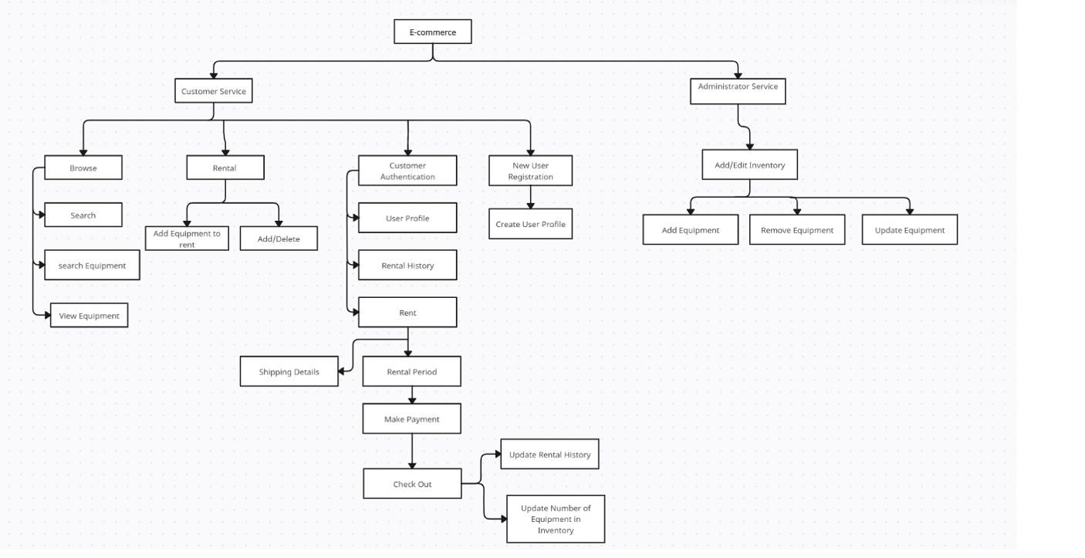

Figure 1: FDD Diagram

### **2.3.2 Justification related to Academic Question**

The proposed e-commerce platform for renting survey equipment directly addresses the academic question in the following ways:

* **Easier and More Enjoyable Rentals:**

The platform simplifies the rental process with an intuitive interface that allows customers to easily browse, check availability, and place orders. Features like equipment details, reviews, and personalized services such as delivery and support enhance the overall user experience, encouraging repeat usage.

* **Improved Accessibility and Operational Efficiency:**

By offering 24/7 access to equipment, the platform enhances accessibility for surveyors and small businesses. Its efficient scheduling and logistics system streamline operations, ensuring timely delivery and return of equipment, minimizing downtime.

* **Cost Reduction and Resource Optimization:**

The platform reduces upfront costs for small businesses and independent surveyors by offering a rental model instead of purchase. This pay-per-use approach allows users to rent equipment only when needed, optimizing resource utilization and reducing waste.

* **Scalability and Growth:**

Designed with scalability in mind, the platform can grow by expanding its inventory, geographic reach, and customer base. Integration with payment systems and strategic partnerships support the platform’s growth, ensuring it remains competitive in the market.

### **2.3.3 Consideration of Other Artefacts**

* **Real-Time Equipment Tracking**:

Implementing GPS or RFID-based tracking for survey equipment can help users monitor the location of rented items in real-time. This feature can reduce the risk of lost or stolen equipment and help both the renters and the platform operators track inventory efficiently.

* **Customer Reviews and Ratings**:

Allow customers to rate and review the equipment and services they rented. This will improve trust and help other users make informed decisions.

* **Discounts and Loyalty Program**:

A system for providing discounts or rewards for frequent customers would encourage repeat rentals and customer loyalty.

* **Payment Gateway and Flexible Payment Options**:

Include multiple payment options like card payments, mobile wallets, and perhaps installment payments for long-term rentals. This would enhance accessibility and appeal to a wider audience.

### **2.3.5 Full Details of Artefact**

### **2.3.6 Development Approach**

The **Scrum methodology** will be employed for the development of the Survey Equipment Rental Platform. Scrum is a widely adopted Agile framework that promotes iterative development, allowing to deliver incremental value at regular intervals. This approach is particularly suitable for my project because it offers a flexible and adaptive framework that accommodates changes in project scope, requirements, and priorities.

### **2.3.7 Justification of Methodology**

Scrum has been selected for this project because of its adaptability, iterative process, and ability to accommodate changing requirements. It helps prioritize tasks, deliver functional increments regularly, and gather feedback for continuous improvement. This approach ensures the platform meets user needs and expectations, while effectively addressing the challenges of the survey equipment rental market. Scrum's flexibility makes it an ideal choice for developing a dynamic, user-friendly platform.

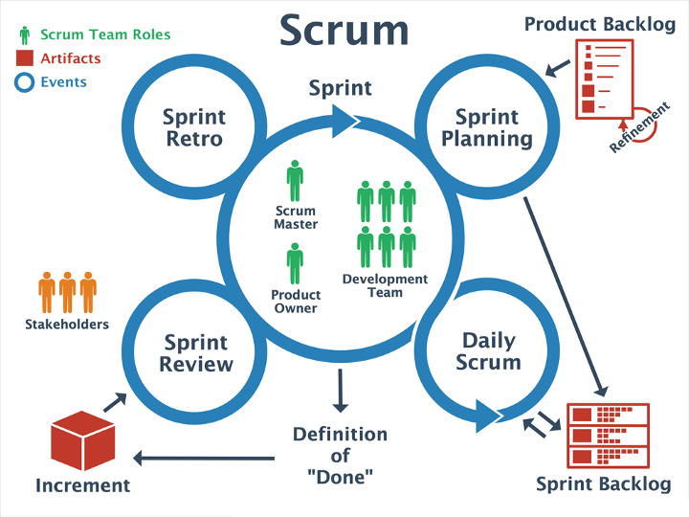

Figure 2: Scrum Methodology

(geeksforgeeks, 2024)

### **2.3.8 Tools and Techniques**

For this project, several tools and techniques will be utilized to ensure efficient development, testing, and deployment of the e-commerce platform for survey equipment rentals. These tools and techniques are chosen based on their suitability for the project requirements and their ability to streamline the development process.

1. **Development Tools**

* **Frontend: React.js**

I chose React.js because it’s a powerful library for building dynamic and interactive user interfaces. Its component-based architecture allows me to break the UI into reusable parts, making it easier to manage and maintain. This also helps ensure the platform looks consistent across all its pages and features.

* **Backend: Node.js and Express.js**

For the backend, I’m using Node.js along with Express.js. Node.js is great for creating scalable and high-performance applications. Express.js complements Node.js by providing a straightforward framework for managing server-side logic and APIs, making the development process smoother and more efficient.

1. **Database Management**

* **Mongo DB**

I choose Mongo DB for database management because a NoSQL database that offers flexibility and scalability. Its document-based structure makes it easy to manage various types of data, such as user profiles, rental equipment details, and booking records.

1. **Design Tools**

* **Figma**

I am using Figma to create wireframes and prototypes for the platform’s user interface. This helps in visualizing the design and gathering feedback from users before moving into development.

1. **Project management Tools**

* **ClickUp**

Agile-based tool that helps in organizing sprints, tracking progress, and keeping the project on schedule. It ensures that milestones are delivered on time and tasks are prioritized effectively.

1. **Version Control**

* **GitHub**

GitHub is essential for managing the project’s source code. It allows for collaboration, keeps a detailed history of changes, and ensures that all versions are well-maintained. This helps in tracking updates and resolving issues efficiently during development.

### **2.3.9 Planned Testing**

* **Unit Testing**

This phase focuses on testing individual components of the platform, such as React frontend components, backend APIs, and database queries, to ensure they function correctly in isolation. By identifying and resolving issues at the component level, unit testing ensures the foundation of the system is robust and reliable. Tools like Jest and React Testing Library will be used to streamline this process.

* **Integration Testing**

Integration testing will verify that various modules of the platform, including the frontend, backend, and database, interact seamlessly. This ensures data flows correctly across the system, such as booking data being correctly processed and reflected in the user interface and database. Tools like Postman will be employed to test API interactions and verify proper integration.

* **Usability Testing**

This phase will evaluate the user experience by assessing the platform's interface, navigation, and overall ease of use. The goal is to ensure the platform is intuitive and user-friendly for a diverse audience, including surveyors and small business owners. Feedback collected from potential users will guide improvements in the design and functionality.

* **Performance Testing**

Performance testing will measure the platform's responsiveness and ability to handle concurrent users under varying load conditions. Using tools like Apache JMeter, scenarios with high traffic and simultaneous bookings will be simulated to identify bottlenecks and ensure the system remains fast and reliable. (Brigginshaw, 2024)

* **User Acceptance Testing**

This will involve real end-users testing the platform in a controlled environment. Surveyors and small business representatives will verify that the platform meets their expectations, addresses their needs, and performs well in real-world scenarios. Their feedback will be used to make final refinements before deployment. (geeksforgeeks, 2024)

# **3. Plan/Schedule**

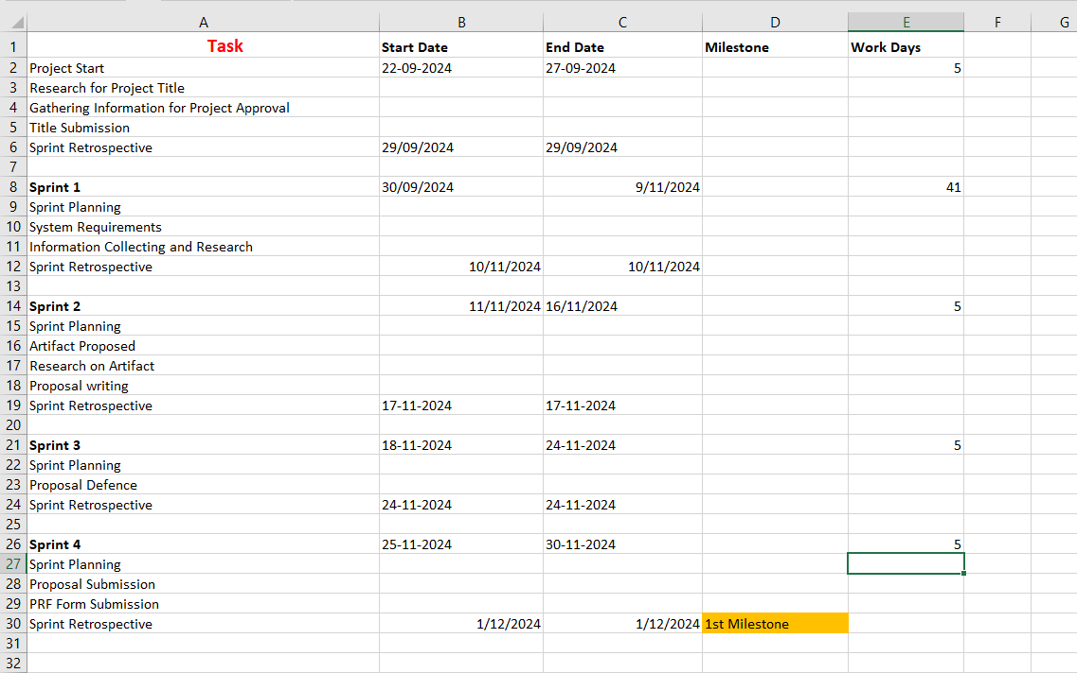

Figure : Gantt Chart

# **4. Additional Information**

## **4.1 Resources**

**Software Requirements**

* Figma for UI/UX design
* GitHub for version control
* Lucid chart for creating UML diagram and WBS
* Microsoft office for report and documentation.
* Visual Studio for development
* ClickUp for project management.

**Hardware Requirements**

* Reliable internet connection for accessing cloud services and collaborating online.
* AWSfor hosting and deploying a project.
* A development computer capable of handling web development.

## **4.2 Client**

The client for this proposal is Mr. Nikunja Lamsal.

# **References**

(2024, May 22). Retrieved from geeksforgeeks: https://www.geeksforgeeks.org/scrum-software-development/

(2024, 09 26). Retrieved from geeksforgeeks: geeksforgeeks

Brigginshaw, D. (2024). *scriptworks.io*. Retrieved from https://www.scriptworks.io/blog/software-testing/

Openko, І. (2024). Economic efficiency of methods for surveying rural infrastructure: assessment of accuracy, cost and duration.